RMRR Records Last updated: 13 Jan 2024

Club inception = 1959 when the predecessor club, Denver Track Club, was foed by Joe Arrazola.

The Rocky Mountain Road Runners were legally and officially formed Jan. 1, 1971. That is the date when the club adopted its current bylaws and became uniquely and independently named the RMRR, separate from the Denver Track Club.
Club Founder Joe Arraloza at the 2005 Awards Banquet

Effective 1/1/2021, RMRR made several changes to the Trophy Series (TS) scoring
- Race walkers will now be scored with runners for the TS score.
- There will be a separate scratch competition for walkers, both race day, ribbons and annual. This was later abolished and walkers are scored with runners – all together.
- 5 km runners (in the longer races) will receive TS points using their handicap (HCP)
- Your HCP will be allowed to go up as much as 2 pts per month if you run slower than your predict.
- Anyone who hasn’t raced in 24 months will be scored as a new member rather than using their old HCP. This was later changed to scoring a runner as new if they haven’t raced in 12 months.

HANDICAP TROPHY SERIES WINNERS
Year | Winner & Points | Second Place | Third Place
2023 | 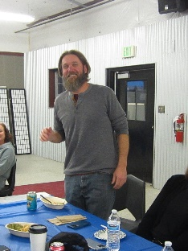  Shane Yommer (752.05/752.05) | 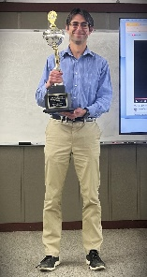  Eric Greene (743.44/845.78) | 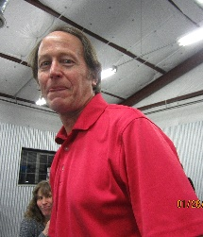  David Rothenburger (728.43/802.51)
2022 | Ken Applegate (730.75/756.08) | Jake Atherton (704.89/753.69) | Will Buck (699.85/699.85)
2021 (10 of 11 races) | Ed Yoblonski (819.18/819.18) | Adam Feerst (664.7/701.21) | Eric Greene (662.72/662.72)
2020 -Covid, so 6 races! | John Shea (494.33/545.64) | Travis Mark (453.24/453.24) | Jeff Olson (447.83/494.08)
2019 | Rick Edrich  (821.97/893.97) | Ric Robinette  (783.19/886.89) | Will Buck  (762.29/762.29)
2018 | Travis Mark  (817.26/867.12) | Ric Robinette  (807.84/832.62) | Brad Labarry  (793.02/908.82)
2017 | Deb Cunningham (775.258/883.914) | Rob Sanchez (772.61/870.559) | Rick Edrich (767.389/820.662)
2016 | Joe Mitchell (807.07/864.85) | Harley Look (797.2/857.2) | Ken Applegate (747.62/)838.65
2015 | Robyn Tibert (809.17/809.17) | Ed Spree (809.08/809.08) | Rick Edrich (762.74/856.46)
2014 | Deb Cunningham  (718.29/778.73) | Ken Shimada  (716.91/809.79) | Scott Newman  (716.89/813.37)
2013 | Ric Robinette (845.20/938.90) | Michael Cosper (843.63/903.63) | Rick Edrich (839.36/890.07)
2012 | Ken Shimada (765.40/874.93) | Mike Knipps (715.21/801.72) | Rich Friedmann (706.99/750.89)
2011 | Link Lubkin (804.50/804.50) | Deb Cunningham (755.46/810.81) | Adam Lee (750.79/750.79)
2010 | Brent Jockers  (737.70/796.27) | Scott Newman  (704.85/704.85) | Theresa Jockers  (685.43/765.53)
2009 | Russell Dion (803.99/803.99) | Rick Edrich (777.60/839.80) | Ken Shimada (773.62/805.26)
2008 | Mike Knipps (780.69/914.59) | Dave Cook (757.89/779.94) | David Rothenburger (747.98/823.22)
2007 | 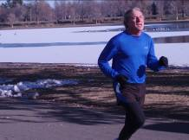  Ric Robinette (825.73/941.51) | Brent Jockers (799.80/799.80) | Theresa Jockers (763.06/763.06)
2006 | 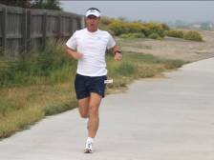  Dennis Depakakibo (851/895) | Bryon Dathe (807/845) | Rick Voorhees (775/885)  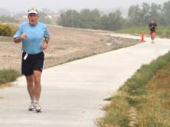
2005 | 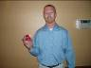  Nick  Benjamin  (784/840) | 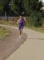  Mark  Stevens  (747/747) | 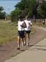  Dave  Mayhew  (745/745)
2004 | Mike Knipps (800/932) | Ric Robinette | Joy Knipps
2003 | Scott McFarlane (764/809) | Richard Martinez | Alicia Nix
2002 | Michael Robbert (883/833) | Ric Robinette | Jim Astle
2001 | John Bullock (797/797) | Michael Knipps | Bonnie Keefe
2000 | Rick Edrich (841/992) | Dave Edrich | Carl Steinhauser
1999 | Alice Voorhees (784/861) | Carl Steinhauser | Greg Woskow
1998 | Edward Baker (869) | Greg Woskow | Rick Brito
1997 | Dave Humphrey (914) | Rick Brito | Ric Robinette
1996 | Brent Jockers (898) | Don Rosenberry | Mark Sisun
1995 | Louise Hecht (988) | Robert (Reo) Olson | Ronald Turner
1994 | William Sierra (885) | Douglas Haak | Rick Brito
1993 | Rafel Pacheco (908) | Ric Robinette | Harold Weatherford
1992 | Yelrah Kool (931) | Rick Brito | Don Kinney
1991 | Richard Kinnie (870) | Michael Broccardo | Michael Hoglund
1990 | Michael Blanchard (842) | Ken Applegate | Ray Hammitt
1989 | Patrick Kamins (912) | John Boucher | Rick Edrich
1988 | Robert (Reo) Olson (967) | Dennis Jouett | Frank Jacobs
1987 | Ric Robinette (915) | Rick Swain | Keith Gatti
1986 | Ann Lawson (912) | Carl Steinhauser | James Fuller
1985 | Brian Wrenshall (935) | Maurice Coleman | Paul Suprono
1984 | Wes Carson (976) | Robert Newman | Patricia Haupt
1983 | Anita Culligan ( 902) | Jeff Stimson | Carol Hanes
1982 | Ric Robinette (1019) | Jim Culligan | Allan Carlson
1981 | Frank Clanton (862) | Neil McLaughlin | Mike Mortenson
1980 | Ed Gussie (939) | Jeff Gussie | Jim McDonald
1979 | Wade Biggs (888) | John McIntosh | Robert Newman
1978 | Ken Prince (862) | Rod Butler | Michael Keefe
1977 | Jane Neimeir (865) | Ken Kopp | Tom Neimeir
1976 | Bob King (929) | Randy Roth | Bob Vinton
1975 | Ed Sardella (853) | Ed Gussie | Roger Cisneros
1974 | John Knisvater (829) | Ed Hagerman | Dennis Jouett
1973 | Ed Hagerman (862) | Roger Gerard | Ed Gussie
1972 | Charlie Wood (a) | Bernie Gray | Joel Wingard
1971 | Gerry Vincent (a) | Bob Welleck | Dave Hershey
1970 | Gerry Vincent (a) | Art Caldwell | Sid Arnold
1969 | Norm Silva (a) | Dennis Kavanaugh | Jeff Carson

(a) Prior to 1972 scoring was done by different formulas and are not comparable to scores after 1972.
(b) From 1999 and forward winners were determined based upon the best 10 of the 12 races scores. Results show the winners and their scores for both all-12/best-10 race results.
From 1972 through 1974 women were scored separate from the men and were given separate awards. The women winners for those years are:

Year | Winner & Points | Second Place | Third Place
1972 | Marilyn Gay | Marcia LeMire | Betty L’Lear
1973 | Laurie Kearns | Patsy Goodman | Betsy White
1974 | Laurie Kearns | Marilyn Gay | Barbara Martin

RACE WALKER TROPHY SERIES WINNERS (starting in 2021, RW scored w/ TS)

Year | Winner & Points | Second Place | Third Place
2020 | Mike Blanchard (473.33/473.33) | Janet Fairs (100/100) | Jan Hill (46.67/46.67)
2019 | Mike Blanchard  (880/880) | Jan Hill  (437.33/437.33) | Janet Fairs  (428/428)
2018 | Mike Blanchard (594.67/594.67) | Jan Hill  (450.67/450.67) | Janet Fairs  (405.33/405.33)
2017 | Jan Hill (920/920) | Mike Blanchard (620/620) | Janet Fairs (320/320)
2016 | Michael Blanchard (940/980) | Jan Hill (713.33/713.33) | Janet Fairs (600/600)
2015 | Michael Blanchard  (833.33/885.33) | Jan Hill  (761.33/761.33) | Janet Fairs (490.67/490.67)
2014 | Michael Blanchard  (853.33/953.33) | Ed Gussie  (686.67/686.67) | Janet Fairs (453.33/453.33)
2013 | Michael Blanchard (758.67/794.67) | Ed Guiff (704.00/704.00) | Jan Hill (594.67/594.67)
2012 | Mike Blanchard (686.67/686.67) | Ed Guiff (646.67/646.67) | Janet Fairs (400.00/400.00)
2011 | Mike Blanchard (753.33/753.33) | Ed Guiff (580/580) | Jan Hill (320/320)
2010 | Janet Fairs  (742.67/742.67) | Ed Guiff  (741.33/821.33) | Mike Blanchard  (604/604)
2009 | Mike Blanchard (757.33/757.33) | Ed Guiff (553.33/553.33) | Jan Hill (512.00/512.00)
2008 | Mike Blanchard (824.00/824.00) | John Lyle (805.33/758.67) | Ed Guiff (708.00/674.67)
2007 | Ed Guiff (873.33/873.33)  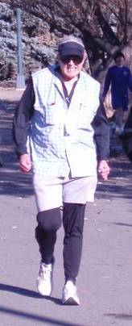 | John Lyle (833.33/833.33)  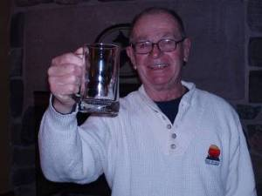 | Mike Blanchard (406.67/406.67)
2006 | Mike Blanchard (857/805) | Chuck Thies (868/781) | Ed Guiff (680/680)
2005  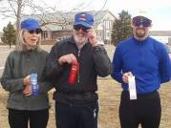 | Mike Blanchard (809) | Jan Hill | Ed Guiff
2004 | Mike Blanchard (828) | Ed Guiff | Jan Hallez
2003 | Ray Adams (824) | John Lyle | Ed Guiff
2002 | Michael Blanchard (996) | John Lyle | Ed Guiff
2001 | Michael Blanchard (853) | John Lyle | Barbara Jensen
2000 | Michael Blanchard (837) | John Lyle | Barbara Jensen
1999 | Barbara Jensen (933) | Mike Blanchard | John Lyle
1998 | Barbara Jensen (883) | Mike Blanchard | John Lyle
1997 | John Lyle (517) | Chris Vanoni | Tracey Hooker
1996 | Michael Blanchard (525) | Chris Vanoni | John Lyle
1995 | Michael Blanchard (529) | John Lyle | John Carroll
1994 | Michael Blanchard (533) | John Lyle | Miki Seeley
1993 | Michael Blanchard (600) | John Lyle | Miki Seeley
1992 | Dick Van Wagenen (579) | John Lyle | Dennis Velasques
1991 | John Lyle (564) | Anthony Zamora | Dan Dea
1990 | John Lyle (635) | Bob Carlson | Dan Dea
1989 | Nancy Hardesty (516) | Ray Franks | Anthony Zamora
1988 | Bob DiCarlo (707) | Ray Franks | Bob Carlson
1987 | Vilmars Strautins (460) | Ray Franks | Bob Carlson

WOMEN’S SCRATCH TROPHY SERIES WINNERS (b)

From 1987 through 1997 there were only eight walk races per year. After 1998 there were 12 walk races per year.

Year | Winner & Points | Second Place | Third Place
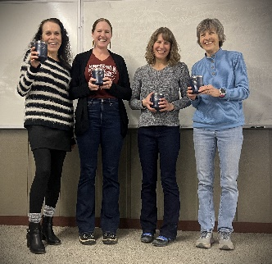  2023 | Deb Cunningham (880.38/950.38) | Melissa Menard (600/600) | Carmen Kitts (507.17/507.17)
2022 | Deb Cunningham (938.45/938.45) | Ruth Serafini (758.35/758.35) | Carmen Kitts (549.74/549.74)
2021 | Deb Cunningham (964.43/964.43) | Emily Finch (535.09/535.09) | Carmen Kitts (517.42/517.42)
2020 | Deb Cunningham (584.31/657.64) | Ruth Serafini (386.12/386.12) | Cori Diekmeier (373.40/373.40)
2019 | Deb Cunningham  (997.84/1093.84) | Beth Sandoval  (936.42/936.42) | Maranke Koster  (873.97/947.30)
2018 | Deb Cunningham (986.89/1080.22) | Elizabeth Sandoval (932.79/932.79) | Maranke Koster (932.66/932.66)
2017 | Deb Cunningham (971.21/1150.61) | Sabine Preisenger (966.88/966.88) | Cori Diekmeier (724.73/771.4)
2016 | Sabine Preisenger (994.57/1091.3) | Maranke Koster (887.25/887.25) | Cori Diekmeier (859.64/859.64)
2015 | Theresa Jockers (948.47/1108.9) | Deb Cunningham (905.37/932.65) | Ruth Serafini (793.42/793.42)
2014 | Deb Cunningham  (983.19/1075.19) | Theresa Jockers  (912.21/1062.15)
2013 | Deb Cunningham (987.22/1175.89) | Stacey Totherow (925.03/1086.72) | Theresa Jockers (873.99/873.99)
2012 | Peyton Dailey (977.19/977.19) | Karen Voss (970.03/970.03) | Theresa Jockers (955.71/1046.30)
2011 | Deb Cunningham (962.34/1049.71) | Theresa Jockers (943.36/943.36) | Bonnie Keefe (840.15/840.15)
2010 | Theresa Jockers  (962.93/1139.32) | Karen Voss (792.16/792.16) | Tina Akin  (636.17/636.17)
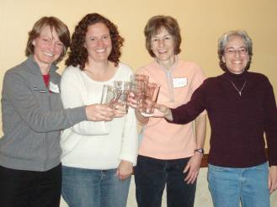  2009 | Deb Cunningham (966.35/1137.02) | Bonnie Keefe (781.78/781.78) | Karen Voss (767.97/767.97)
2008 | Theresa Jockers (1036.75/952.75) | Bonnie Keefe (895.06/895.06) | Micol Rothman-Haji (872.88/872.88)
2007  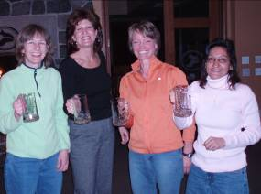 | Deb Cunningham (1039.69/952.32) | Theresa Jockers (925.92/925.92) | Denise Glenn (688.63/688.63)
2006  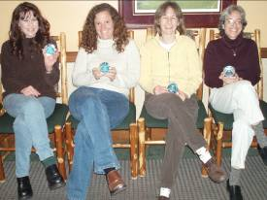 | Bonnie Keefe (1149/972) | Deb Cunningham | Stephanie Struble
2005  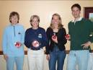 | Deb Cunningham (1152/975) | Bonnie Keefe | Bethanie Werner
2004 | Deb Cunningham (1173/983) | Bonnie Keefe | Kolene Brown
2003 | Deb Cunningham (1188/1000) | Bonnie Keefe | Kolene Brown
2002 | Deb Cunningham (996/996) | Leslie Mitchell | Bonnie Keefe
2001 | Deb Cunningham (976/976) | Michelle Hancock | Bonnie Keefe
2000 | Carita Hobson | Olga Hnizdil | Kerry Hauger
1999 | Carita Hobson (1190/1000) | Kerry Hauger | Olga Hnizdil
1998 | Carita Hobson (1000) | Janet Hagen | Jill Cook
1997 | Susan Himelstieb (949) | Janet Hagen | Olga Hnizdil
1996 | Susan Himelstieb (1139) | Theresa Chavez Jockers | Janet Pappen-Hughes
1995 | Rae Marie Smilanic (1138) | Susan Himelstieb | Louise Hecht
1994 | Rae Marie Smilanic (1107) | Heidi Schutt | Susan Himelstieb
1993 | Trish Filly (1074) | Olga Hnizdil | Barbara Anders
1992 | Theresa Chavez (1189) | Diane Schloemer | Barbara Anders
1991 | Barb Krosley (1107) | Vonnie Nelson | Olga Hnizdil
1990 | Rae Marie Smilanic (1118) | Barb Krosley | Christine Poplaskie
1989 | Charlotte Aycrigg (986) | Loretta Ulibarri | Martha Cross
1988 | Cheryl Beckwith (1172) | Lynn McEwen | Vonnie Nelson
1987 | Cheryl Beckwith (1145) | Jan Kiehl | Barb Krosley
1986 | Cheryl Beckwith (1155) | Rachella Seeley | Janet Hagen

From 1999 and forward winners were determined based upon the best 10 of the 12 races scores. Results show the winners and their scores for both all 12/best10 race results.

MEN’S SCRATCH TROPHY SERIES WINNERS (b)
Year | Winner & Points | Second Place | Third Place
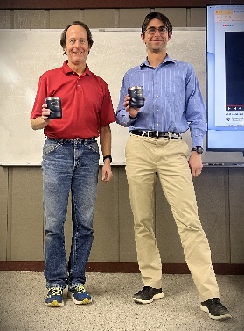  2023 | Eric Greene (991.31/1185.69) | Jake Atherton (986.22/1174.79) | David Rothenburger (825.77/825.77)
2022 | Eric Greene (996.67/1188.89) | Jake Atherton (980.38/1075.53) | Will Buck (910.05/910.05)
2021 | Eric Greene (998.18/998.18) | Travis Mark (978.2/978.2) | Adam Feerst (935.56/935.56)
2020 | Eric Greene (600/698.43) | Travis Mark (580.66/580.66) | Adam Feerst (575.19/667.19)
2019 | Eric Greene  (1000/1200) | Travis Mark  (976.13/1071.56) | Adam Feerst  (908/984.29)
2018 | Eric Greene (997.3/1193.59) | Travis Mark (970.04/1057.73) | Jackie McCush (887.83/887.83)
2017 | Eric Greene (1000/1198.93) | David Rothenburger (977.63/1060.49) | Scott Dailey (928.58/1015.55)
2016 | Eric Greene (998.43/1077.56) | David Rothenburger (925.66/1065.31) | Matthew Cecere  (912/912)
2015 | Eric Greene (995.25/1089.43) | David Rothenburger (954.54/1131.98) | Scott Newman (874.37/874.37)
2014 | Brian Cheek  (980.52/980.52) | Eric Greene  (978.11/978.11) | David Rothenburger  (97.27/1067.2)
2013 | Eric Greene (983.47/1076.51) | Steven Johnson (955.46/1137.36) | David Rothenburger (936.01/1118.43)
2012 | Eric Greene (995.52/995.52) | David Rothenburger (954.58/1130.32) | Steven Johnson (945.40/945.40)
2011 | Eric Greene (980.31/1072.69) | Scott Kukel (938.53/1021.23) | David Rothenburger (919.10/1087.99)
2010 | Scott Kukel  (963.08/1144.67) | Eric Greene  (941.54/941.54) | David Rothenburger  (936.40/1113.36)
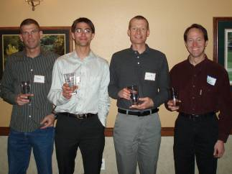  2009 | Scott Kukel (971.22/1136.67) | Eric Greene (947.89/947.89) | David Rothenburger (930.40/1106.68)
2008 | Scott Kukel (985.86/1162.63) | Adam Feerst (965.92/1057.04) | David Rothenburger  (943.02/1120.52)
2007  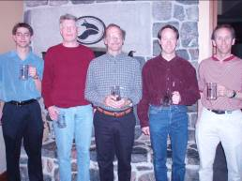 | Tim Gentry (972.26/972.26)  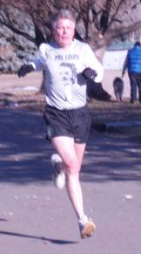 | Adam Feerst (968.12/968.12)  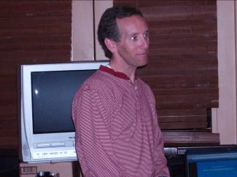 | David Rothenburger (907.67/1070.35)
2006  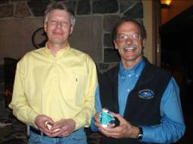 | Tim Gentry (984/1080) | Mike Quispe | Bob Basse  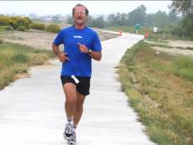
2005  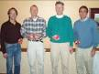 | Tim Gentry (987/1174) | Scott Kukel | Devin Croft
2004 | Scott Kukel (981/1164) | David Rothenburger | Rick Edrich
2003 | Adam Feerst (984/1078) | Scott Kukel | Rick Edrich
2002 | Jason Saitta (998/998) | Adam Feerst | Jeff Lynn
2001 | Adam Feerst (976/1069) | Rick Edrich | Jonathan Skripko
2000 | Adam Feerst (980/980) | Rick Edrich | Jonathan Skripko
1999 | Adam Feerst (976/1163) | Jonathan Skripko | Ken Applegate
1998 | Adam Feerst (1151) | John Bullock, Jr. | Jonathan Skripko
1997 | Ken Applegate (1103) | John Bullock, Jr. | Mark Sisun
1996 | Ken Applegate (1130) | Mark Sisun | Don Rosenberry
1995 | Ken Applegate (1126) | Ric Robinette | Rick Edrich
1994 | Devin Croft (1161) | Glenn Erickson | Ray Hammitt
1993 | Glenn Erickson (1172) | Ken Applegate | Rick Edrich
1992 | Ray Hammitt (1196) | Daniel Haney | Glenn Erickson
1991 | Richard Ames (1187) | Daniel Haney | Glenn Erickson
1990 | Andrew Maynard (1167) | Ray Hammitt | Tom Groves
1989 | Tim Diaz (1073) | Keith Gatti | Ken Applegate
1988 | Dale Peterson (1191) | Aubrey Lavizzo | Ed Yoblanski
1987 | Tonny Van Loij (1156) | Michael Whitney | Ed Yoblonski
1986 | Hal Wheatley (1124) | Robert Hannigan | David Morgan

RESOLUTE RUNNER WINNERS
Year | Winner & Points | Second Place
2023 | 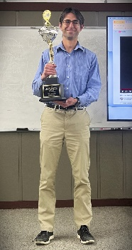  Eric Greene (2712.65) | 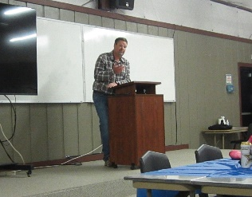  Scott Newman (2592.36)
2022 | Adam Feerst (2678.98) | Rick Edrich (2652.34)
2021 | Ric Robinette (2,716.44) | Adam Feerst (2,665.79)
2020 | Ric Robinette (2,854.997) | Deb Cunningham (2,846.819)
2019 | Ric Robinette
2018 | Eric Greene (2992.83) | David Rothenburger (2951.57)
2017 | David Rothenburger (2932.57) | Eric Greene (2912.44)
2016 | Scott Newman (2917.18) | David Rothenburger (2890.82)
2015 | Scott Newman (2981.994) | David Rothenburger(2974.723)
2014 | David Rothenburger (3025.13) | Deb Cunningham (2999.02)
2013 | David Rothenburger (3037.23) | Jeff Olson (2913.82)
2012 | David Rothenburger (3084.59) | Jeff Olson (2871.97)
2011 | David Rothenburger (3176.93) | Scott Kukel (2819.75)
2010 | David Rothenburger (3075.22) | Ken Applegate (2954.51)
2009 | 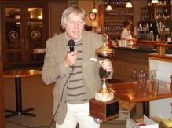  Ric Robinette (3123.06) | Ken Applegate (3069.12)
2008 | Mike Knipps (3222.65) | David Rothenburger (2872.16)
2007 | Mike Knipps  (3240.33)  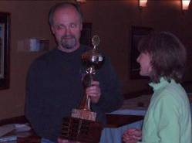 | Ric Robinette (3113.32)
2006 | 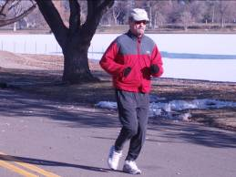  Mike Knipps (3284.5) | Deb Cunningham
2005 | 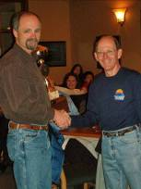  Mike Knipps (3170) | Deb Cunningham
2004 | Mike Knipps (3257) | Rick Edrich
2003 | Rick Edrich (3263) | Ric Robinette
2002 | Rick Brito (3005) | Ric Robinette
2001 | Rick Brito (3096) | Jeff Olson
2000 | Rick Brito (3242) | Ric Robinette
1999 | Ric Robinette (3098) | Rick Brito
1998 | Rick Brito (3053) | Ric Robinette
1997 | Rick Brito (3070) | Ric Robinette
1996 | Ric Robinette (3061) | Richard Kinnie
1995 | Ric Robinette (2941) | Richard Kinnie
1994 | Ric Robinette (3061) | Patrick Kamins
1993 | Ric Robinette (3115) | Patrick Kamins
1992 | Ric Robinette (2960) | Ray Hammitt
1991 | Ric Robinette (2955) | Ken Applegate
1990 | Ric Robinette (3102) | Ken Applegate
1989 | Ken Applegate (2886) | Ed Yoblonski
1988 | Richard Kinnie (3026)
1987 | Richard Kinnie (2913)

Most Resolute Runner Wins
13 | 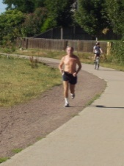  Ric Robinette (2019-2021, 2009, 1999,  1990-1996, 1 earlier)
6 | David Rothenburger (2010, 2011, 2012, 2013, 2014, 2017)
5 | Mike Knipps (2008, 2007,  2006, 2005, 2004)
5 | Rick Brito
Most Resolute Runner Points
3284.5 | Mike Knipps 2006
Largest Margin of victory Resolute Runner
357.18 | David Rothenburger over Scott Kukel (2011)
350.49 pts | Mike Knipps over David Rothenburger (2008)
Smallest Margin of victory Resolute Runner
7.271 pts | Scott Newman over David Rothenburger (2015)
8.178 pts | Ric Robinette over Deb Cunningham (2020)

Joe Arrazola Award Winners – given to a long time member with service to the club.
2008 | John Lyle  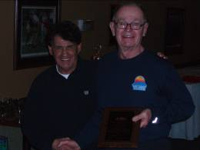
2007 | Ric Robinette
2006 | Ken Simons

TS Full Year Wins
Male Scratch
9 consecutive  10 Total | Eric Greene | 2015-2023
4 consecutive  5 Total | Adam Feerst | 1998-2001, 2003
3 consecutive  4 total | Scott Kukel | 2008-10, 2004
3 | 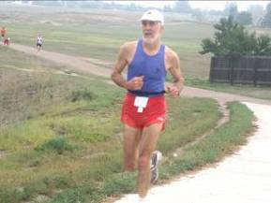  Ken Applegate | 1995-97
3 | Tim Gentry | 2005-2007

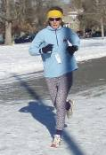
Female Scratch
7 consecutive  17 total | Deb Cunningham |  | 2001-05, 2007, 2009, 2011, 2013, 2014, 2017-2023
3 | Theresa Jockers |  | 2008, 2010, 2015
3 | Carita Hobson |  | 1998-2000
3 | Cheryl Beckwith |  | 1986-88
TS
4 | Ric Robinette |  | 1982, 1987, 2007, 2013
2 Consecutive | Gerry Vincent | 1970-71
2 Consecutive | Laurie Kerns* | 1973-74
2 | Rick Edrich |  | 2000, 2019
2 | Deb Cunningham |  | 2014, 2017
2 | Mike Knipps |  | 2008, 2004
2 | Jerry Vincent |  | 1971, 1972
Race Walk
20 total. 6 consecutive.  2011-2016. | Mike Blanchard  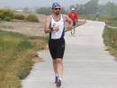 |  | 1993-96, 2000-02, 2004-06, 2008-09, 2011-2016,2018, 2019
3 | John Lyle |  | 1997, 1991, 1990
2 | Barb Jensen |  | 1998-1999
*Women were scored separately in 1972-1974

TS Records for best 10 of 12 races
*Best 10 of 12 Race format started in 1999
Most points scored by TS 10 race format
Male Scratch
1000 | Eric Greene | 2019, 2017
998.43 | Eric Greene | 2016
998 | Jason Saitta | 2002
Female Scratch
1000 | Deb Cunningham | 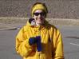  2003
1000 | Carita Hobson | 1999
997.84 | Deb Cunningham | 2019
Overall (score for best 10 of 12 races)
851 | 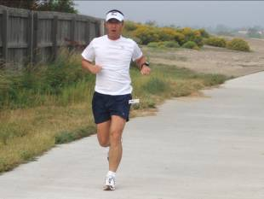  Dennis Depakakibo |  | 2006
845.20 | Ric Robinette |  | 2013
843.63 | Michael Cosper |  | 2013 – 2nd place

TS Records for 12 race series*
*12 race format started in 1972, ended in 1998. Prior to 1972 there was a 16 race format & misc formats before that.
Most Points scored by TS 12 race format
Male Scratch 12 race format
1196 | Ray Hammitt | 1992
1191 | Dale Peterson | 1988
1187 | Richard Ames | 1990
Female Scratch 12 race format
1190 | Theresa Chavez / Jockers | 1992
1172 | Cheryl Beckwith | 1988
1155 | Cheryl Beckwith | 1986
Overall
1019 | 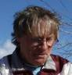  Ric Robinette |  | 1982
993 | Jim Culligan |  | 1982
992 | Rick Edrich |  | 2000
987 | Louise Hecht |  | 1987
976 | Wes Carlson |  | 1984
967 | Robert (Reo) Olson |  | 1988
964 | Allan Carlson |  | 1982

Smallest Margin of Victory TS winner – full year
.09 pts | Robyn Tibert over Ed Spree (809.17-809.08) | 2015
.90 pts | Ken Prince over Rob Butler | 1978
1.38 pts | 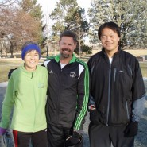  Deb Cunningham over Ken Shimada. The top 3 finishers (Scott Newman -3rd, Ken Shimada – 2nd & Deb Cunningham – 1st ) were within 1.4 pts of each other. This picture was taken just before the December race. | 2014
1.57 pts | Ric Robinette over Michael Cosper (845.20-843.63) | 2013
Smallest Margin of Victory Scratch
Men
2.3 pts | Andrew Maynard over Ray Hammitt | 1990
2.41 pts | Brian Cheek over Eric Greene | 2014
4.14 pts | Tim Gentry over Adam Feerst | 2007
Women
.09 pts | Bonnie Keefe over Deb Cunningham | 2006
4.23 pts | Deb Cunningham over Sabine Preisinger | 2017
7.16 pts | Peyton Dailey over Karen Voss | 2012
Smallest Margin of Victory Racewalk TS winner
1.34 pts | Janet Fairs over Ed Guiff | 2010
2.66 pts | 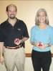  Mike Blanchard  Over  Jan Hill | 2005

Full year: Largest Margin of Victory TS winner
154.48 | Ed Yoblonski | 2021 – 11 races
129.3 | Patrick Kamins | 1989
65.8 | Robert (Reo) Olson | 1988
54.9 | Brent Jockers | 1996
Full year: Largest Margin of Victory Male Scratch
88.2 | Ken Applegate | 1995
72.77 | Eric Greene | 2016
53.8 | Wade Biggs | 1979
Full year: Largest Margin of Victory Female Scratch
429.34 | Deb Cunningham | 2021 – 11 races
248.6 | Theresa Jockers | 1992
185 | Cheryl Beckwith | 1986
Largest Margin of Victory Race walk
442.67 pts | Mike Blanchard over Jan Hill | 2019
373.33 | Mike Blanchard over Janet Fairs | 2020 – Covid shortened
300 pts | Jan Hill over Mike Blanchard | 2017

Largest decrease in old vs new handicap
Male
75 pts | Jay Holmes | Dec 2015
70 pts | Nam McCush | Jan 2021
57 pts | Brian King | Feb 1995
Female
140 pts | Kristin Haller | Aug 2000
80 pts | Paige Dailey | Aug 2018
57 pts | Lu Shaw | July 2018
Walkers
30 pts | Barb Jansen | June 2004
16 pts | John Lyle | Feb 2007
14 pts | Sheila Molde | Feb 2005

Lowest Handicap Ever
 | Date | Distance | Time | Time/mile | Handicap
Male
Frank Shorter | Apr 1975 | 9.0 miles | 45:15 | 5:01.7 | 13
John Gregorio | June 1974 | 3.0 miles | 14:58 | 4:59.3 | 17
Tom Duits & Bob Lewis* | May 1981 | 5.0 miles | 24:42 | 4:56.4 | 18
Female
Liz Brittan (age 17) | July 1984 | 2.2 miles | 12:34 | 5:42.7 | 47
Maureen Custy-Roben | Jan. 1984 | 7.0 miles | 43:28 | 6:12.6 | 48
Sue Oran | May 1978 | 6.2 miles | 38.38 | 6:13.9 | 49
Walkers
Mike Blanchard | May 1995 | 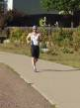 |  |  | 83
Ray Franks | June 1988 |  |  |  | 84
Mike Polum | Aug 1989 |  |  |  | 94
*race run in major rain storm and Duits & Lewis finished hand in hand

Handicap Lower than Age
Name | Gender | Age | Handicap | Difference | Date | Distance
Frank Shorter | M | 27 | 13 | 14 | Apr 1975 | 9 miles
Tom Bailey | M | 55 | 44 | 11 | Mar 1987 | 3 miles
Tom Duits | M | 24 yr 11 mo | 18 | 6 | May 1981 | 5 miles
Jon Gregorio | M | 23 yr 5 mo | 17 | 6 | Jun 1974 | 3 miles
Devin Croft | M | 52 | 48 | 4 | Nov 2005 | 10 miles

Longest TS Scratch Win Streak
Male
Eric Greene | 20 | Jan 2019 – Mar 2021 (No Feb Race – bad weather)
Eric Greene | 14 | June 2015 – July 2016
Mike Montano | ? | 1980-81
Richard Ames | 7 | 1995
Jason Saitta | 5 | Jan-May 2002
Female
Carita Hobson | 30 | Jan 1999-June 2000. Had 1000 scratch pts in 2000, so 12 wins: 12+12+6=30
Bette Poppers | 20+ | 1980-81
Deb Cunningham | 18 | April 2002-Sept 2003
Theresa Jockers | ?
Walker
Mike Blanchard | ? | 1998-1999

Oldest Individual Scratch Winners (Individual TS race)
Male
53 | Keith Johnson | August 2014
52 | 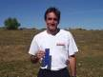  Devin Croft | Sept 2005, Nov 2005
49 | Tim Gentry | October 2011
49 | Adam Feerst | November 2009
Female
62 years, 20 days | 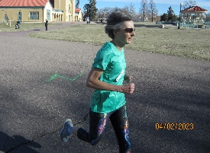  Deb Cunningham | 3 Dec 2023
54 years, 129 days | 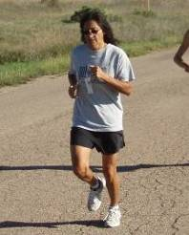  Theresa Jockers | 1 Nov 2015
48 yrs, 217 days | Sabine Preisinger | 3 Sep 2017

Walkers (Scratch)
72 | Rita Sinkovec | Aug 2012
69 | John Lyle | Nov 2002
68 | Ed Guiff | Nov 2012
68 | Richard Ellis | Oct 2007

Youngest Individual Scratch Winners (Individual TS race)
Male
16 | Jon Sinclair | July 1974
16 | Christopher Hammitt | July & Aug 1997
16 | Joel Jones | Dec 1980
Female
11 | Peyton Dailey | July 2011
14 | Ellie Ross | Mar 2018
16 | Jacqueline Mariash | Aug 1997
Walkers
33 | Mike Blanchard | June 1994

Oldest Individual TS Winners (Individual TS race)
Male
85 yrs, 206 days | Ross Westley | Mar 2022
78 yrs, 120 days | Howard Kumpf | Oct 2019
78 yrs, 82 days | Lee Bengston | Nov 2015
Female
64 | Leslie Thompson | Dec 2020
60 | Lu Shaw | July 2018
59 | Kathleen Hancock | June 2014
Walkers (TS, non-scratch)
77 | Jerry Wischmeyer | December 2018
76 | Janet Fairs | January 2020
76 | Richard Ellis | August 2015

Youngest Individual TS Winners (Individual TS race)
Male
5 | Nick Serafini | Jan 2022
6 | Jared Carringan | Aug 1992
8 | Sean Hartley | May 1977
Female
3 yrs 338 days | Marie Serafini | Jan 2023
9 | Savannah Sanchez | June 2013
11 | Peyton Dailey | July 2011
11 | Susan Kaspari | June 1986
Walkers
27 | George Dyer | April 1995

Best finish by related runners in an individual TS race
Kim Gussie (1st), Ed Gussie (2nd), Jeff Gussie (3rd) (Sept 1979)
Bob Williams (1st), Karl Williams (11th), Max Williams (12th) (Aug 1982)
Kevin & Jan Kiehl (Husband & Wife) 1 & 2 (Dec 1995)
Tom & Marcia Lemire (Husband & Wife) 1 & 2 (June 1970) Denver Track Club Race

Best finish by related runners in TS Season
Joe Mitchell (1st), Harley Look (2nd), Susan Look (6th), Krista Mitchell (7th) | 2016
Ed Gussie (1st), Jeff Gussie (2nd), Kim Gussie (7th) | 1979
Kristin Mott (1st) and Michael Cosper (3rd) (Partners) | 2013
Brent Jockers (1st) and Theresa Jockers (3rd) (Husband & Wife) | 2010
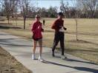  Mike Knipps (1st) and Joy Knipps (3rd) (Husband & Wife) | 2004
Jane Neimeier (1st) and Tom Neimeier (3rd) (Wife & Husband) | 1977
Brent Jockers (2nd) and Theresa Jockers (3rd) (Husband & Wife) | 2007
Bonnie Keefe (5th) and Doug Smith (12th) (Husband & Wife) | 2006

Youngest Scratch Winners (Full Year Results)
Male
29 | Andrew Maynard | 1990
30 | Richard Ames | 1991
30 | Ric Robinette | 1982
Female
13 | Peyton Dailey | 2012
29 | Carita Hobson | 1998
30 | Charlotte Ayrcrigg | 1989

Oldest Scratch Winners (Full Year Results)
Male
49 | 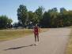  Ken  Applegate | 1997
45 | Tim Gentry | 2007
44 | Ray Hammitt | 1992
Female
62 | Deb Cunningham | 2023
54 | Theresa Jockers | 2015

Oldest TS Winners (Full Year Results)
Male
76 | Ed Yoblonski | 2021 (11 races)
74 | Ken Applegate | 2022
63 | John Shea | 2020 (Covid – Shortened)
Female
56 | Deb Cunningham | 2017
47 | Alice  Bedard  Voorhees | 1999
45 | Anne Lawson | 1986
Walkers
67 | Ray Adams | 2003
63 | Ed Guiff | 2007
62 | Bob Carlson | 1987

Youngest TS Winners (Full Year Results)
Male
14 | Wes Carlson |  | 1984
29 | Nick Benjamin |  | 2005
30 | Ric Robinette |  | 1982
Female

Biggest gap between TS wins – scratch
Time Span | Name | First Win | Latest Win
42 years, 11 months | Mike Blanchard 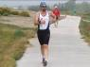 | December 1980 (running) | Nov 2023 (race walker). Stopped scoring walkers separately in 2022.
22 years, 9 months | Deb Cunningham  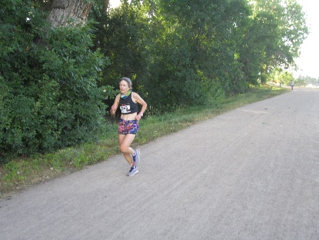 | March 2001 | Dec 2023
19 years, 1 months | Karen Voss | December 1994 | Jan 2013

Most Scratch wins
Male
90 | Eric Greene  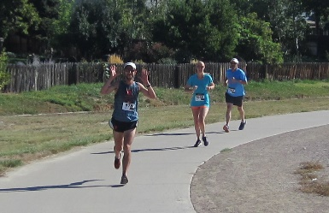 | 1 (2024) + 5(2023)+ 9(2022) + 7(2021) + 6 (2020) + 12 (2019) + 6 (2018) + 11 (2017) +9(2016) + 7(2015) + 2(2014) + 2 (2013) + 8(2012) + 42011)
35 | Mike Montano
19 | Lee Courkamp
8 | Jake Atherton | 6(2023) +2(2022)?
Female
84 | Deb Cunningham  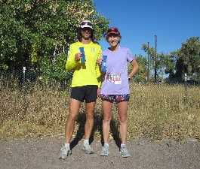 | 3(2023) + 6(2022) + 5(2021) + 3(2020) + 9(2019) + 4(2018) + 2(2017) + 3(2015) +5 (2014) + 6(2013) +2(2011) + 3(2009) +2 (2008) +1 (2007) + 4 (2006) + 4 (2005) + 5 (2004) + 10 (2003) + 4 (2002) + 5 (2001)
40 | Karen Voss | 4 (2012) + 3(2011) + 5(2010) + 3(2009) + 8 (2008) + 5 (2007) + 3 (2006) + 3 (2005) + 3 (2004) + 1 (2003) +1 (2001) + 1 (1994)
37 | Bette Poppers
27 | Trish Filley
18+ | Teresa Jockers | 2(2015) + x (2014) + x (2013) 3(2012) + 2 (2011) + 1(2010) +1(2008) +1(2007) +8 (1996)
7 | Melissa Menard | 1 (2024) + 6(2023)

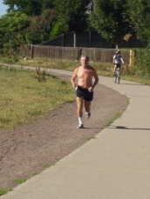
Longest TS streak (consecutive races participated in)
372 | Ric Robinette | Streak ended with Mar 2017 TS.
356 | 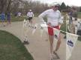  Jeff Olson | Active - after Jan 2024 TS
231 | David Rothenburger | Active – after Jan 2024 TS
153 | Mike Knipps | Streak ended with Sept 2013 TS.
141 | Chuck Thies  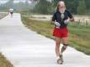
139 | 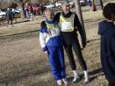  Janet Gold

Member for the longest time
51 years: Dennis Kavanaugh 1968 - 2019
46 years: Ken Simons 1967-2013. Not a member in December 2014.
42 years: Michael Blanchard Dec1980- 2022
30+ years: Rick Edrich, Ken Applegate, Ric Robinette, Janet Gold, Jeff Olson

Worst Conditions at a TS Race
Date | Venue | # runners + walkers beating handicap | Reason
12/6/09 | 4.5 mi @ Wash Park | 0/47=0.00% | 15 degrees, wind chill below 0, 3” new snow, 100 yards visibility  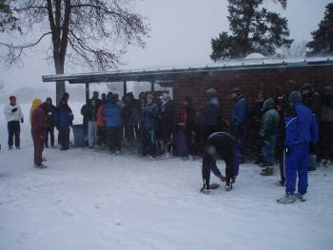
7/4/23 | 4k @ Bible Park | 0/35 = 0.0% | 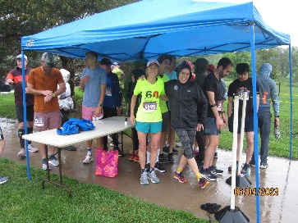  Pouring rain. 55 degrees. Most runners didn’t warm up and took it easy.
1/12/92 | 7 Mi @ Wash Park | 1/117 = .85% | Cold w/ Snow on ground
1/11/11 | 10k @ Twin Lakes | 1/59 = 1.69% | 24 degrees, snowed overnight with snow packed course. A plow came through during the race.
2/14/11 | Platte River path @ Platte River B&G | 1/50 = 2.00% | Snowed overnight and early morning up to race time.
1/7/96 | 7 Mi @ Wash Park | 2/98 = 2.04%
1/7/06 | Twin Lakes Park | 1/47 = 2.13% | Icy and snow-drift covered course
10/10/12 | Cottonwood Park | 1/39=2.56% | Cold – mid 30s after 80s prior week. Wind from the north

Temperature extremes at a TS Race
Date | Venue | Temperature
March 3, 2019 | 3 mile @ Crown Hill | 2 degrees at race time with a slight breeze from the north. Snowed the night before. Course was plowed, but still had an inch of snow on it. Mass start. Only 39 participants.
February 2008 | 3 mile @ Crown Hill | 3 degrees at race time. No wind, but very cold.
January 5, 2014 | 10k @ Twin Lakes | 13 degrees at race time, but 9 MPH wind making wind chill below 0. Snow on ground and snowing during race. Two pickup truck snowplows passed us on the course.
August 1, 2008 | 5k @ deKoevend | Daytime high was 104

Largest # people running a TS
273 May 1978
268 April 1978
232 March 1978

2000 Decade
189 June 2013
159 Apr 2010
157 Mar 2010

Largest # members in RMRR
1988 was peak

Club member deaths while running:
Rich Klassen of a heart attack during 9 Mile TS at Sloan’s Lake on April 16, 1982
Don Kemp of a heart attack on a training run June 1, 1982
Jack Buck died during a ½ Marathon in Phoenix

5k Accompanying a Longer TS Course Records. 5ks started in 2011.
Time | Name | Date
Twin Lakes Park (Jan TS)
20:41 | Scott Dailey |  | Jan 2012
27:00 | Jen Lallier |  | Jan 2013
Platte River Trail (Feb 2022 Couse)
22:04 | Daniel Rice |  | Feb 2023
27:54 | Lindsay Fryer |  | Feb 2022
Platte River Trail (Feb TS 2020 Course)
22:30 | Nicholas Dunford |  | Feb 2020
20:30 | Brooke Kish |  | Feb 2020
Platte River Trail (Feb TS 2019 Course)
19:51 | Eric Greene |  | Feb 2019
27:58 | Caitlyn Truong |  | Feb 2019
Platte River Trail (Feb TS – 2018 and Earlier)
19:03 | 19:03 |  | 19:03
21:27 | 21:27 |  | 21:27
Stapleton’s Central Park (May TS)
18:38 | Jay Winkelhake |  | May 2014
21:26 | Sabine Preisinger |  | May 2014
Riverwalk Ballfields (Thornton)
20:27 | Derek Griffiths |  | Sept 2021
25:06 | Cori Diekmeier |  | Sept 2021
Trailhead Park (Sep or Jan TS)
18:02 | Andrew Halverson |  | Sep 2016
23:20 | Annelise Howell |  | Jan 2019
Star K Ranch (Oct TS)
21:23 | Chin Go |  | Oct 2021
31:07 | Harleigh Sanchez |  | Oct 2022
Beck Rec Center (Oct TS)
21:44 | Richard Malcolm |  | Oct 2019
28:58 | Lisa Wilson |  | Oct 2019
Thornton Carpenter Park (Oct TS)
30:43 | Carmen Kitts |  | Oct 2016
20:09 | Mike Quespe |  | Nov 2018
Cottonwood Park (Oct TS)
20:36 | Neil McDonagh |  | Oct 2014
23:55 | Sarah Hellman |  | Oct 2012
Prairie Gateway Park (Nov TS)
17:28 | Tripp Hipple |  | Nov 2013
21:58 | Erin Donnellyo |  | Nov 2016
Westminster City Park (Nov TS)
18:50 | Steven Johnson |  | Nov 2011
22:51 | Jennifer Oney |  | Nov 2011

Course Records
Time | Name | Date
2 Mile Races
2 Mile at Stone House Park (July TS) New Course as of July 2023
11:10 | Jake Atherton | July 2023
14:44 | Melissa Menard | July 2023
21:55 | Jan Hill | July 2023

Mile at Stone House Park (July TS) New Course as of July 2018
11:21 | Eric Greene | July 2022
13:16 | Jayme Brindle | July 2019
22:04 | Michael Blanchard | July 2019

2 Mile at Stone House Park (July TS) New Course as of July 2018
11:21 | Eric Greene | July 2022
13:16 | Jayme Brindle | July 2019
22:04 | Michael Blanchard | July 2019
2 Mile at Stone House Park (July TS) July 2012-July 2017
10:49 | Eric Greene | July 2012
12:49 | Jayme Brindle | July 2016
19:25 | Mike Blanchard | July 2012
2 Mile at Expo Park (July TS) New Course as of July 2011
10:42 | Mike Irwin | July 2011
13:54 | Peyton Dailey | July 2011
24:23 | Ed Guiff | July 2011
2 Mile at Bible Park (July TS) New Course as of 5/31/09
10:47 | Kiefer Johnson | June 2010
13:19 | Ginger Knott | June 2010
18:11 | Mike Blanchard | June 2009
2 Mile at Bible Park (July TS) original course
10:33 | 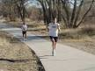  Jason Saitta | July 2002
13:31 | Karen Voss | July 2008
17:44 | Mike Blanchard | July 2004
2 Mile at Big Dry Creek (Aug TS)
11:38 | Rafael Pacheco | Aug 1999
12:37 | Carita Hobson | Aug 1999
18:10 | Mike Blanchard | Aug 1999
2 Mile at Addenbrooke Park (June TS)
10:11 | Chad Flynn | June 1998
12:25 | Theresa Chavez Jockers | June 1996
15:29 | Mike Blanchard | June 1995
2 Mile at Rocky Mountain Lake Park (June TS)
9:29 | Ronn Smith | Aug 1974
11:39 | Bette Poppers | June 1983
16:56 | Ray Franks | June 1987
2 Mile at Red Rocks Business Park (June TS)
10:31 | Mike Cordova | June 1989
12:38 | Allyson Robbins | June 1989
18:06 | Ray Franks | June 1988
2 Mile at Field Street Park (June TS)
10:38 | Dale Petersen | June 1988
12:20 | Rae Marie Smilanic | June 1988
16:19 | Ray Franks | June 1988
2 Mile at Berkeley Lake Park (July TS)
9:38 | John Lunn | Jun 1972
12:45 | Pam Young | Jun 1972
2 Mile at Wash Park (October TS)
9:33 | Steve Matthews | Aug 1967
13:39 | Pam Weigle | Jun 1971
2.2 Mile Races
2.2 Mile at DeKoevend Park (July TS)
11:52 | 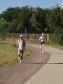  Mike Montano | July 1985
13:22 | Barb Early | July 1985
2.2 Mile at Twin Lakes Park (July TS)
11:18 | Dan Haney | July 1994
13:41 | Theresa Chavez Jockers | July 1996
17:39 | Mike Blanchard | July 1996
2.2 Mile at Wash Park (July or Aug TS)
10:43 | Lee Courkamp | June 1964
12:55 | Bette Poppers | July 1984
17:39 | Mike Blanchard | July 1996
2.3 & 2.4 Mile Races
2.3 Mile at Stone House Park (July TS)
12:47 | Chad Flynn | July 1999
14:07 | Emily Knaub | July 1999
20:45 | Mike Blanchard | July 1999
2.4 Mile at Stone House Park (June TS)
13:26 | Keith Johnson | June 2009
16:02 | Karen Voss | June 2004
21:04 | Mike Blanchard | June 2006
2.4 Mile at City Park (June TS)
13:45 | Tim Gentry | June 2005
16:01 | Angie Anderson | June 2005
21:11 | Mike Blanchard | June 2005
4k Races
4k @ Bible Park (June TS) (June 2023 Course with mud bowl)
14:13 | Jake Atherton | June 2023
18:27 | Melisa Menard | June 2023
29:14 | Jan Hill | June 2023
4k @ Bible Park (June TS)
13:03 | Brad Lowery | June 2013
16:44 | Peyton Dailey | June 2012
23:54 | Mike Blanchard | June 2012
3 Mile Races
3 Mile at Crown Hill Park (March TS) (New course as of 2015)
16:39 | Eric Greene | March 2016
19:57 | Jayme Brindle | March 2016
31:42 | Mike Blanchard | March 2017
3 Mile at Crown Hill Park (March TS)
15:43 | Richard Ames | March 1994
19:27 | Amy Barnish | March 1993
23:54 | Mike Blanchard | March 1995
3 Mile at Utah Park (March TS)
15:41 | John Custy | March 1988
19:19 | Cheryl Beckwith | March 1988
28:47 | Bob DiCarlo | March 1988
3 Mile at Sloans Lake (March or July TS)
14:38 | John Hunsaker | March 1978
18:55 | Bette Poppers  Suzy Tanner | March 1980  April 1978
26:46 | Dennis Crock | March 1987
3 Mile at Wash Park (June TS)
14:28 | Steve Matthews | Apr 1967
20:51 | Pam Weigle | Dec 1970
21:50 | Floyd O’Meara | Feb 1970 (racewalk)
5K Races
5k at Johnson Reservoir (March TS)
17:27 | Jake Atherton | Mar 2023
24:39 | Ruth Serafini | Mar 2023
33:11 | Jan Hill | Mar 2023
5k at DeKoevend Park (August 2016 course)
16:48 | Tristan Mitchell | Aug 2016
22:11 | Sabine Preisinger | Aug 2016
32:44 | Michael Blanchard | Aug 2016
5k at DeKoevend Park (June or August TS)
16:00 | Jonathan Huie | Aug 2011
20:05 | Emily Knaub | June 1999
28:18 | Mike Blanchard | June 1999
5k at Sloans Lake (July TS)
16:44 | Chad Flynn | July 1998
20:27 | Carita Hobson | July 1998
27:05 | Mike Blanchard | July 1998
5k at Clement Park (July or Aug TS)
16:45 | Ray Hammitt | Aug 1994
19:38 | Theresa Chavez Jockers | Aug 1996
24:44 | Mike Blanchard | Aug 1995
5k at Twin Lakes Park (Aug TS)
16:43 | Dan Haney | Aug 1993
20:44 | Trish Filley | Aug 1993
24:40 | Mike Blanchard | Aug 1993
5k at Prospect Park (Aug TS)
16:58 | Ray Hammitt | Aug 1992
20:05 | Theresa Chavez | Aug 1992
28:31 | Dennis Velasquez | Aug 1992
5k at Lake Arbor (Aug TS)
16:34 | Tom Donohoue | Aug 1991
20:05 | Amy Lopina | Aug 1991
28:53 | Jack Wackwitz | Aug 1991
5k at Kennedy Golf Course (Aug TS)
16:55 | Mike Cordova | Aug 1989
20:05 | Allyson Robbins | Aug 1989
26:40 | Ray Franks | Aug 1988
5k at Utah Park (Mar TS)
15:41 | John Custy | Mar 1988
19:19 | Cheryl Beckwith | Mar 1988
28:47 | Bob DiCarlo | Mar 1988
5k at Berkeley Lake Park (Jul or Aug TS)
16:08 | Mike Montano | July 1981
19:29 | Bette Poppers | July 1978
29:09 | Maurice Coleman | Aug 1987
5k at Wash Park (Jul TS)
15:00 | Jeff Norman | July 1976
19:58 | Barbara Martin | July 1976
4 Mile Races
4 Mile at City Park (new course as of April 2023)
22:53 | Jake Atherton | Apr 2023
32:33 | Deb Cunningham | Apr 2023
4 Mile at City Park (new course as of April 2021) |  |  |  | Apr 2021
22:42 | Eric Greene | Apr 2022
31:11 | Deb Cunningham | Apr 2021
46:51 | Michael Blanchard | Apr 2021
4 Mile at City Park (new course as of April 2008)
21:41 | Chris Knott | Apr 2014
27:56 | Karen Voss | Apr 2008
38:15 | Mike Blanchard | Apr 2009
4 Mile at City Park (new course for April 2006)
23:56 | Tim Gentry | Apr 2006
28:05 | Karen Voss | Apr 2006
35:36 | Mike Blanchard | Apr 2006
4 Mile at Bear Creek Bike Path (new course as of April 1999)
21:47 | Jason Saitta | Apr 2002
25:53 | Carita Hobson | Apr 1999
35:47 | Mike Blanchard | Apr 2001
4 Mile at Bear Creek Bike Path - old course (Apr or Oct TS)
21:01 | John Custy | Oct 1985
26:00 | Lynn McEwen | Oct 1989
31:50 | Mike Blanchard | Apr 1995
4 Mile at Wash Park (Oct TS)
19:37 | John Gregorio | Nov 1972
24:50 | Bette Poppers | Oct 1981
4 Mile at Cheeseman Park (Feb TS)
20:34 | Steve Acuff | Nov 1974
27:04 | Bette Poppers | Feb 1979
4 Mile at Bible Park (Feb TS)
20:26 | Mike Bordell | Feb 1976
28:48 | Marsha Heining | Feb 1976
4.4 Mile Races
4.4 Mile at Wash Park (Dec TS)
22:29 | Doug Nelson | Dec 1990
27:18 | Susan McCabe | Dec 1989
38:19 | Mike Blanchard | Dec 1995
4.5 Mile Races
4.5 Mile at Wash Park (Dec TS)
24.23 | Lonnie Cruz | Dec 2014
30:11 | Sharon Gallant-Pierce | Dec 2017
46:16 | Mike Blanchard | Dec 2012
4.75 Mile Races
4.75 Mile at Fed Center (May TS)
26:29 | Chad Flynn | May 1998
31:48 | Carita Hobson | May 1998
45:00 | Sally Richards | May 1998
5 Mile Races
5Mile at Beck Rec Center (October TS)
30:28 | Eric Greene | Oct 2020
38:52 | Deb Cunningham | Oct 2020
60:51 | Mike Blanchard | Oct 2020
5 Mile at Stapleton’s City Park (May TS)
27:34 | Brad Lowery | May 2013
34:15 | Ginger Knott | May 2010
47:56 | Mike Blanchard | May 2012
5 Mile at Carson Nature Center (on dirt next to South Platte Trail) (May TS)
27:25 | Jason Saitta | May 2006
37:13 | Deb Cunningham | May 2006
44:55 | Mike Blanchard | May 2006
5 Mile at Carson Nature Center (South Platte Trail) (May TS)
28:19 | Jason Saitta | May 2003
35:04 | Karen Voss | May 2004
44:58 | Mike Blanchard | May 2005
5 Mile at FRCC/Big Dry Creek Trail (May TS)
27:36 | Jason Saitta | May 2001
33:53 | Carita Hobson | May 2000
48:45 | Mike Blanchard | May 2001
5 Mile at Federal Center (Apr or May TS)
26:41 | John Custy | May 1985
32:29 | Lynn McEwan | Apr 1990
40:49 | Mike Blanchard | May 1995
5 Mile at Wash Park (Dec TS)
24:58 | Steve Matthews | Jun 1968
31:31 | Bette Poppers | Dec 1981
43:33 | Ray Franks | Dec 1987
5 Mile at City Park (May or June TS)
24:24 | Tom Duits & Bob Lewis | May 1981
32:41 | Val Ranum | May 1983
5 Mile at DeKoevend Park (May TS)
28:02 | Mike Montano | June 1979
38:06 | Maureen Collar | June 1979
5 Mile at Arapahoe HS (Jan TS)
25:49 | Charlie Messenger | Jan 1971
43:30 | Laurie Kearns | Jan 1973
6 Mile Races
6 Mile at Sloans Lake (May TS)
31:18 | Lee Courkamp | Aug 1971
41:01 | Donna Messenger | Feb 1973
6 Mile at Wash Park (May TS)
30:38 | Steve Matthews | May 1967
44:53 | Pam Weigle | May 1972
10K Races
10K at Riverwalk Ballfields Thornton 2023+ course (Sep TS)
35:42 | Eric Greene | Sept 2023
46:16 | Melissa Menard | Sept 2023
1:22:15 | Michael Blanchard | Sept 2023
10K at Riverwalk Ballfields Thornton 2022+ course (Sep TS)
36:52 | Eric Greene | Sept 2022
52:23 | Deb Cunningham | Sept 2022
1:15:53 | Michael Blanchard | Sept 2022
10K at Riverwalk Ballfields Thornton – Pre 2022 course (Sep TS)
37:32 | Eric Greene | Sept 2021
1:08:24 | Ha Nguyen  Caitlyn Truong | Sept 2021
1:14:45 | Michael Blanchard | Sept 2021
10K at TrailHead Park (Jan TS)
35:25 | Thomas Robbins | Jan 2024
44:03 | Theresa Tufaro | Jan 2020
1:08:28 | Michael Blanchard | Jan 2020
10K at Twin Lakes (Jan TS)
35:17 | Tristan Mitchell | Jan 2009
44:38 | Karen Voss | Jan 2007
59:35 | Mike Blanchard | Jan 2006
10K at City Park (Jan or Feb TS)
33:13 | Richard Ames | Feb 1991
39:21 | Susan McCabe | Jan 1990
51:54 | Mike Blanchard | Feb 1995
10K at Wash Park (Dec TS)
31:54 | Steve Matthews | Nov 1967
44:18 | Sandra Garratt | Jan 1979
10K at DeKoevend Park (May TS)
34:39 | Henry Barksdale | May 1978
38:38 | Sue Oran | May 1978
10K at Sloans Lake (May TS)
31:31 | Robbert Fitts | May 1976
43:18 | Carolyn Jarrett | May 1977
10K in Vail (Sep)
34:14 | Damien Koch | Sep 1971
7 Mile Races
7 Mile on S. Platte River Bike Path (from Reynolds Landing) (Feb 2022)
41:20 | Jake Atherton | Feb 2023
50:33 | Jayme Brindle | Feb 2022
7 Mile on S. Platte River Bike Path (from Platte River Bar & Grill) (Feb 2020 course) – short @ 6.93 Mil
40:45 | Glen Mays | Feb 2020
49:48 | Jayme Brindle | Feb 2020
1:21:05 | Mike Blanchard | Feb 2020
7 Mile on S. Platte River Bike Path (from Platte River Bar & Grill) (Feb 2019 course)
42:55 | Eric Greene | Feb 2019
52:51 | Deb Cunningham | Feb 2019
1:17:28 | Mike Blanchard | Feb 2019
7 Mile on S. Platte River Bike Path (from Platte River Bar & Grill) (Feb 2014 course)
38:50 | Lonnie Cruz | Feb 2015
48:00 | Jayme Brindle | Feb 2017
1:17:33 | Mike Blanchard | Feb 2017
7 Mile on S. Platte River Bike Path (from Platte River Bar & Grill) (Feb 2012 course)
42:01 | Brian Cheek | Feb 2013
52:15 | Karen Voss | Feb 2012
1:12:18 | Mike Blanchard | Feb 2013
7 Mile on S. Platte River Bike Path (from Platte River Bar & Grill) (2011 Course)
41:04 | Tristan Mitchell | Feb 2010
53:30 | Karen Voss | Feb 2010
1:12:26 | Mike Blanchard | Feb 2010
7 Mile at Cherry Creek State Park (Feb or Mar TS) Course starting from West lot
40:27 | Marcus Corbett | Feb 2009
50:52 | Sarah Szymanski | Feb 2009
1:11:31 | Mike Blanchard | Feb 2009
7 Mile at Cherry Creek State Park (Feb or Mar TS)
35:36 | Derek Griffiths | Feb 2003
46:54 | Carita Hobson | Mar 2000
1:07:22 | Mike Blanchard | Mar 2001
7 Mile at Wash Park (Jan TS)
36:47 | Frank Mencin | Jan 1976
43:28 | Maureen Custy | Jan 1982
1:04:46 | Mike Blanchard | Jan 1999
12k Races
12k @ Star K Ranch (Sand Creek)
44:45 | Eric Greene | Oct 2023
58:23 | Melissa Menard | Oct 2023
1:30:03 | Mike Blanchard | Oct 2021
8 Mile Races
8 Mile at Beck Rec Center (Oct TS)
48:58 | Eric Greene | Oct 2019
1:00:30 | Deb Cunningham | Oct 2019
1:31:00 | Mike Blanchard | Oct 2019
8 Mile at Carpenter Park (Oct TS)
49:25 | Eric Greene | Oct 2018
1:01:18 | Deb Cunningham | Oct 2018
No race walkers – USATF race held same time
8 Mile at Trailhead Park (Sept TS)
46:10 | Eric Greene | Sep 2016
55:29 | Sabine Preisinger | Sep 2014
1:21:18 | Mike Blanchard | Sep 2012
8 Mile at Platte River Bar & Grill (Sept TS)
46:04 | Tristan Mitchell | Sep 2009
59:03 | Karen Voss | Sep 2009
1:19:16 | Mike Blanchard | Sep 2009
8 Mile at Chatfield – new course as of 10/2004 (Oct TS)
47:36 | 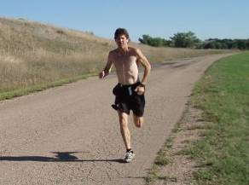  Keith Johnson | Sep 2008
58:59 | Bonnie Keefe | Oct 2006
1:16:07 | Mike Blanchard | Oct 2005
8 Mile at Chatfield – old course (Sept or Oct TS)
43:42 | John Custy | Sept 1985
55:11 | Bette Poppers | Oct 1983
1:17:24 | Mike Blanchard | Oct 2001
8 Mile at Waterton (Sept or Oct TS)
44:59 | Andrew Maynard | Sept 1989
53:51 | Allyson Robbins | Sept 1989
1:14:37 | Mike Blanchard | Oct 1998
8 Mile at Highline Canal (Sept TS)
43:50 | Dale Petersen | Sept 1986
56:49 | Mary Greer | Sept 1986
8 Mile at Martin Marietta (Sept TS)
46:39 | Rich Beavers | Sept 1981
57:23 | Rachella Seeley | Sept 1981
8 Mile at Viele Lake (Sept TS)
45:46 | Mike Montano | Sept 1978
55:01 | Bette Poppers | Sept 1978
8 Mile at Cherry Creek Reservoir (Sept TS)
44:40 | Ed Bingham | Sept 1976
1:08:03 | Bette Poppers | Sept 1976
8 Mile at Wash Park (Sept TS)
41:43 | Mike Lohman | Aug 1973
53:36 | Betsy Harrcrier | Sept 1975
9 Mile Races
9 Mile at Thornton’s Carpenter Park – new course as of 9/2016
1:08:28 | Deb Cunningham | Nov 2018
52:21 | Jonathan Huie | Nov 2018
1:40:17 | Mike Blanchard | Oct 2016
9 Mile at Prairie Gateway Park (Rocky Mountain Arsenal) – new course as of 11/3/2013
54.18 | Eric Greene | Nov 2017
1:04:35 | Sabine Preisinger | Nov 2014
1:37:12 | Mike Blanchard | Nov 2011
9 Mile at Twin Lakes – new course as of 10/2010
52:35 | Peter Lucas-Roberts | Oct 2010
1:05:41 | Suzette Bossart | Oct 2010
1:41:19 | Ed Guiff | Oct 2010
9 Mile at Westminster City Park – new course as of 10/2007 – this is 0.1 miles too short
55:23 | Hector Martinez | Oct 2007
1:06:06 | Karen Voss | Oct 2007
1:51:16 | Richard Ellis | Oct 2007
9 Mile at Westminster City Park – new course as of 9/2005 w/o 1m around park.
55:27 | Adam Feerst | Nov 2008
1:01:06 | Nicole Hahn | Nov 2011
1:25:11 | Mike Blanchard | Sept 2006 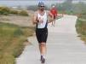
9 Mile at Westminster City Park – new course as of 9/2004 – 2003 edition was 0.25 miles too long (Sept TS)
57:29 | Tim Gentry | Sept 2004
1:06:45 | Deb Cunningham | Sept 2004
1:27:49 | Mike Blanchard | Sept 2004
9 Mile at Carson Nature Center/Platte River Bike Path (Sept or Oct TS)
50:58 | Jason Saitta | Sept 2002
1:05:54 | Susan Bellard | Sept 2001
1:26:02 | Mike Blanchard | Sept 2001
9 Mile at Cherry Creek Reservoir (Apr TS)
47:15 | Robert Herdon | Apr 1991
1:01:56 | Lynn McEwan | Apr 1990
9 Mile at Clear Creek (Sept or Oct TS)
50:56 | David Swiderski | Sept 1994
1:01:56 | Carita Hobson | Oct 1998
1:25:25 | Mike Blanchard | Oct 1998
9 Mile at Gates Crescent Park (Apr TS)
52:55 | Mike Keefe | Apr 1983
1:04:11 | Val Ranum | Apr 1983
9 Mile at Sloans Lake (Apr TS)
53:20 | Don Waller | Apr 1982
1:01:41 | Marilyn McCarthy | Apr 1982
Rich Klassen died of a heart attack during this race on April 16, 1982
9 Mile at Wash Park (Apr TS)
45:15 | Frank Shorter | Apr 1975
1:02:26 | Bette Poppers | Apr 1981
9 Mile at Wheat Ridge Bike Bath
52:05 | Kurt Nichols | 1995, 96 or 97
1:06:37 | Susan Himelsteib | 1995, 96 or 97
9.15 Mile Races
9.15 Mile at Barr Lake (Sept TS)
56:14 | Chad Flynn | Sept 1999
1:02:59 | Carita Hobson | Sept 1999
1:29:11 | Mike Blanchard | Sept 1999
15K Races
15K, but long at Prairie Gateway Park (Nov TS)
56:24 | Eric Greene | Nov 2023
1:23:18 | Jitka O’Farrell | Nov 2023
1:58:54 | Mike Blanchard | Nov 2023
15K at Prairie Gateway Park (Nov TS)
55:38 | Jake Atherton | Nov 2022
1:14:54 | Erin Donnelly | Nov 2021
1:50:07 | Mike Blanchard | Nov 2021
15K at Barr Lake (Sept TS)
56:22 | Rob Wright | Sept 2000
1:08:01 | Michelle Hancock | Sept 2000
1:33:48 | Mike Blanchard | Sept 2000
15k at Wash Park
48:22 | Charlie Messenger | 1967
10 Mile Races
10 Mile at Trailhead Park (Sep TS)
1:04:58 | Eric Greene | Sep 2020
1:19:11 | Lindsey Gerard | Sep 2020
2:08:21 | Michael Blanchard | Sep 2020
10 Mile at Prairie Gateway Park (Nov TS)
1:06:58 | Josh Pilkington | Nov 2016
1:17:26 | Sabine Priesinger | Nov 2016
2:01:19 | Jan Hill | Nov 2016
10 Mile on Cherry Creek Trail from Cottonwood Park – (Oct TS)
59:57 | Eric Greene | Oct 2015
1:15:50 | Peyton Dailey | Oct 2012
1:46:56 | Mike Blanchard | Oct 2012
10 Mile at Big Dry Creek – (Nov or Sep TS)
59:58 | Eric Greene | Oct 2016
1:12:37 | Shannon Filar | Nov 2010
1:49:59 | Michael Blanchard | Sep 2019
10 Mile at Waterton – (Oct or Nov TS)
56:29 | Jason Siatta | Nov 2006
1:13:48 | Ginger Knott | Oct 2009
1:40:40 | Mike Blanchard | Oct 2009
10 Mile at deKoevend – 11/2005 (Nov TS)
1:01:53 | Tim Gentry  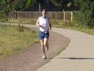 | Nov 2005
1:13:21 | Karen Voss | Nov 2005
1:45:42 | Mike Blanchard | Nov 2005
10 Mile at Twin Lakes (Nov TS)
1:02:01 | Scott Poston | Nov 2002
1:11:53 | Susan Bellard | Nov 2001
2:17:04 | John Lyle  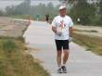 | Nov 2001
10 Mile Arapahoe High School (Nov TS)
54:01 | Wes Crist | Nov 197x?
1:05:32 | Pam Allen | Nov 1976
10 Mile at Bear Creek (Nov TS)
56:06 | John Custy | Nov 1985
1:07:24 | Susan McCabe | Nov 1989
10 Mile at Carson Nature Center (Nov TS)
56:38 | Ralph Rodriquez | Nov 1994
1:09:30 | Theresa Chavez | Nov 1992
1:34:18 | Mike Blanchard | Nov 1998
10 Mile at DeKoevend Park (Nov TS)
57:15 | Rick Katz | Nov 1978
1:14:03 | Bette Poppers | Nov 1978
10 Mile at Inverness Business Park (Nov TS)
54:42 | Jim Gusek | Nov 1979
1:08:23 | Bette Poppers | Nov 1980
10 Mile at Red Rocks Business Park (Nov TS)
58:50 | Leroy Archuleta | Nov 1986
1:15:32 | Cheryl Beckwith | Nov 1986
10 Mile at Wash Park (Sept TS)
53:37 | Craig Runyan | May 1967
12 Mile Races
12 Miles at Wash Park (Aug )
1:06:03 | Lee Courkamp | Aug 1971
1:29:55 | Pam Weigle | Aug 1971
20K Races
20k at Wash Park
64:51 | Floyd Godwin | Oct 1967
15 Mile Races
15 Mile at Arapahoe HS (Mar)
1:24:46 | Tom Berger | Mar 1972
1:53:01 | Pam Weigle | Mar 1972
25K Races
25k at Wash Park
81:28 | Steve Matthews | Mar 1968
30K Races
30k at Wash Park
1:42:38 | Steve Matthews | 1969
20 Mile Races
20 Mile at Arapahoe HS (Apr)
1:57:32 | Steve Matthews | Apr 1971
2:40:18 | Pam Weigle | Apr 1972
Marathon
Marathon at Wash Park
2:28:56 | Floyd Godwin | Feb 1967
3:19:11 | Pam Weigle | May 1972

Timed Runs
1/2 Hour Run
4 miles, 640 Yards | Pam Weigle | 197x?
1 Hour Run
10 Miles, 987 Yards | John Landwehr | Jun 1972

